

Lab #& Genetic Algorithm
Artificial Intelligence
SUBMITTED BY:
UBAID AHMAD
ROLL NO:
2410-0011
SUBMITTED TO:
Ma’am Wardah Asad
DATE:
29/03/2026

Task 1:
Write Python code for N-Queen problem Implementation using Genetic Algorithm.
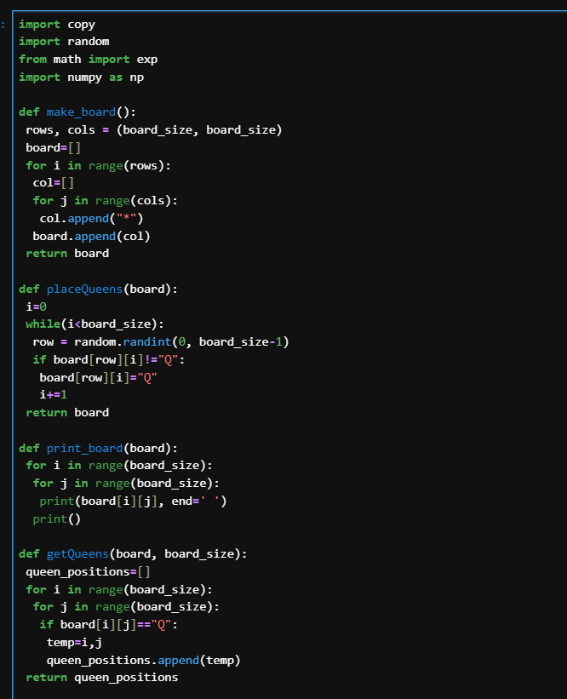
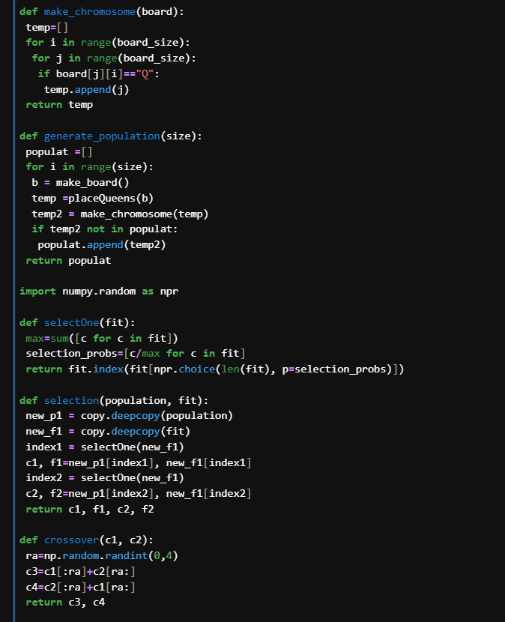

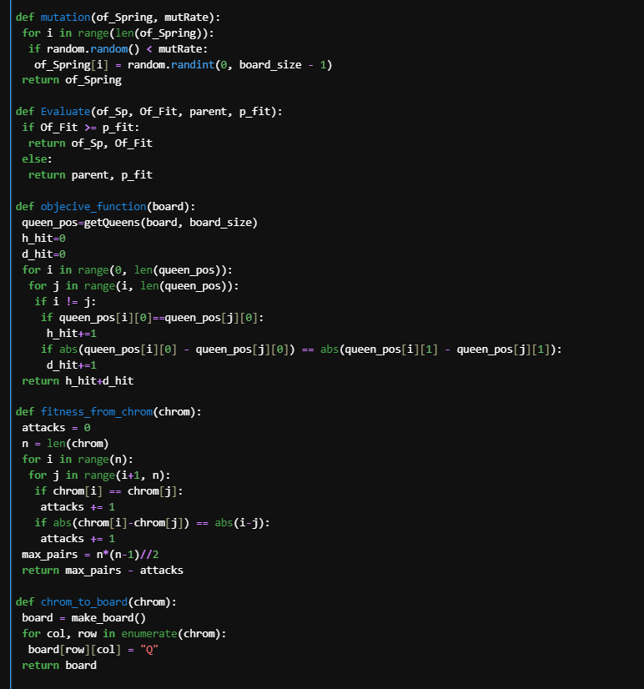
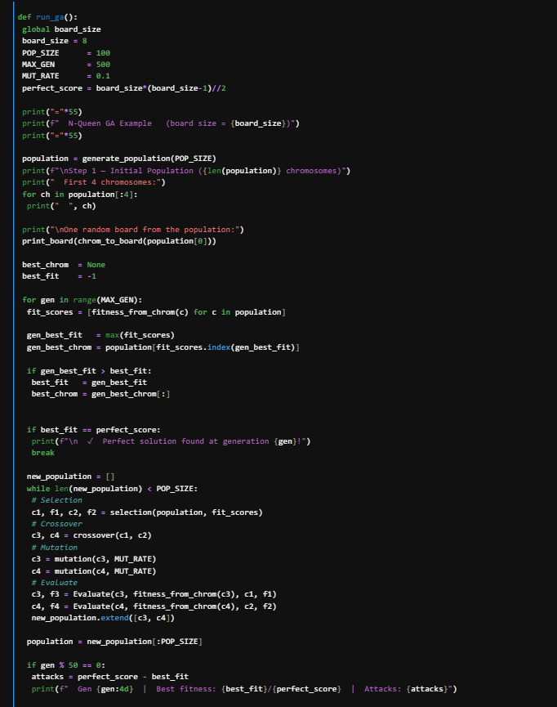
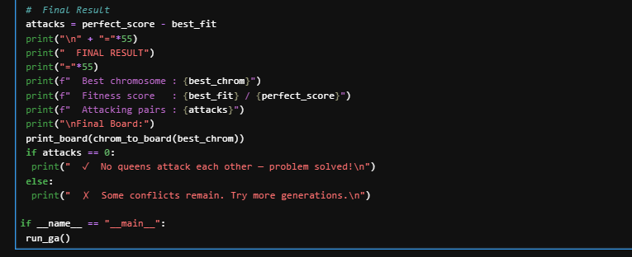

OUTPUT:
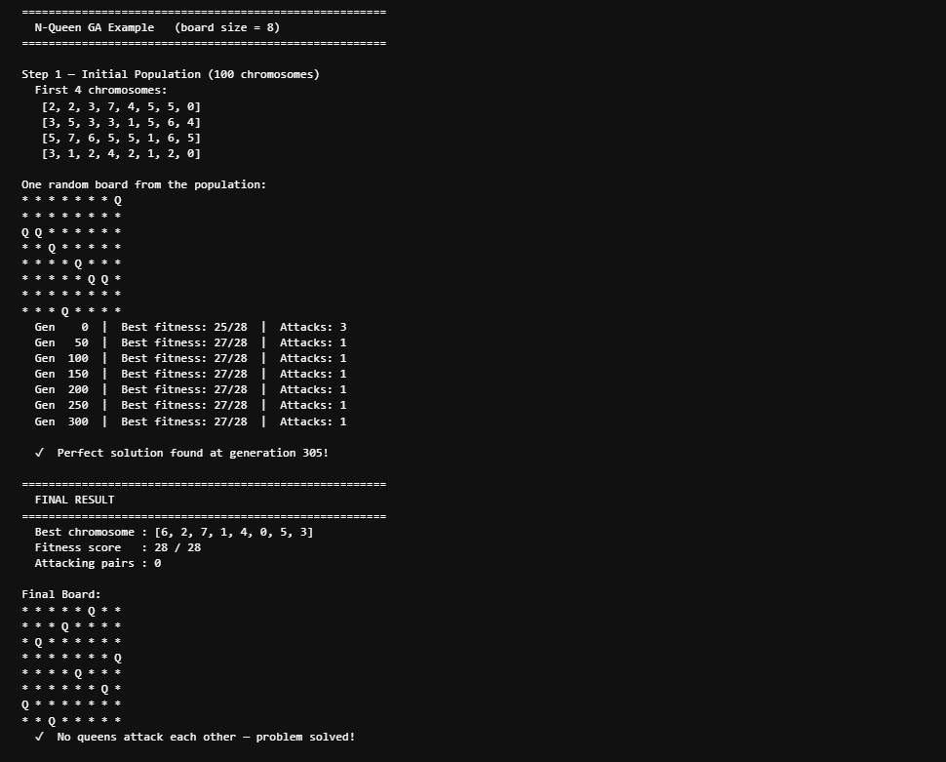
TASK 2:
Understand the working of the code step-by-step and analyze + explain how each function behaves.
For every function, write:
- What is the purpose of the function?
- What are its inputs (parameters)?
- What does it return?
Step-by-step explanation of every function:
- Make_board():
- Purpose
Creates and returns an empty N x N chess board. Every cell is initialized with '*' to represent an empty square.
- Inputs
No parameters. Uses global variable board_size.
- Returns
A 2D list (list of lists) of size board_size x board_size, filled with '*'.
- placeQueens(board):
- Purpose
Places exactly N queens on the board — one queen per column — at randomly chosen row positions. Uses a while loop to ensure each column gets exactly one queen.
- Inputs
board: A 2D list (the empty board created by make_board()).
- Returns
The same board (2D list) with 'Q' placed in N positions, one per column.

- print_board(board):
- Purpose
Displays the board to the console in a readable grid format. Each cell is printed separated by a space, with a newline after each row.
- Inputs
board: A 2D list representing the chess board.
- Returns
Nothing (None). It only prints to the console.

- getQueens(board, board_size):
- Purpose
Scans the entire board and collects the (row, col) position of every queen found. This list of positions is later used by the objective function to check conflicts.
- Inputs
board: 2D list of the board. board_size: Integer size of the board.
- Returns
A list of tuples e.g. [(0,2),(1,4),...] representing queen positions.

- make_chromosome(board):
- Purpose
Converts a board layout into a chromosome (a compact list). The chromosome is a list of length N where chromosome[col] = row of the queen in that column. This representation is used for the GA operations.
- Inputs
board: 2D list of the board with queens placed.
- Returns
A list of integers of length board_size. Example: [2, 4, 1, 3, 0] for a 5-queen board.
- generate_population(size):
- Purpose
Generates the initial population of chromosomes for the GA. It creates 'size' number of unique random chromosomes by placing queens on random boards and converting them to chromosomes.
- Inputs
size: Integer — how many chromosomes to generate.
- Returns
A list of chromosomes (list of lists). Each chromosome is a unique list of length board_size.
- selectOne(fit):
- Purpose
Performs roulette-wheel (fitness-proportionate) selection. Chromosomes with higher fitness have a higher probability of being selected. It converts raw fitness values into selection probabilities.
- Inputs
fit: A list of fitness scores (integers) for the population.
- Returns
An integer — the index of the selected chromosome in the population.
- selection(population, fit):
- Purpose
Selects two parent chromosomes from the population using roulette-wheel selection (calls selectOne twice). These two parents will be used for crossover to produce offspring.
- Inputs
population: List of chromosomes. fit: List of fitness scores.
- Returns
Four values: c1 (parent 1 chromosome), f1 (its fitness), c2 (parent 2 chromosome), f2 (its fitness).
- crossover(c1, c2):
- Purpose
Performs single-point crossover between two parent chromosomes. A random crossover point is chosen and the two parents swap their tails to produce two new children. This mimics biological reproduction.
- Inputs
c1: First parent chromosome (list). c2: Second parent chromosome (list).
- Returns
Two new child chromosomes: c3 = c1[:point] + c2[point:] and c4 = c2[:point] + c1[point:].
- mutation(of_Spring, mutRate):
- Purpose
Introduces random changes in a chromosome to maintain diversity and avoid getting stuck in local optima. Each gene (queen position) has a mutRate probability of being replaced with a random row value.
- Inputs
of_Spring: A chromosome list to be mutated. mutRate: A float between 0 and 1 (e.g. 0.1 = 10% chance per gene).
- Returns
The mutated chromosome (list of integers).

- Evaluate(of_Sp, Of_Fit, parent, p_fit):
- Purpose
Compares the offspring's fitness against the parent's fitness and returns the better one. This ensures that the next generation is never worse than the current — it prevents regression.
- Inputs
of_Sp: Offspring chromosome. Of_Fit: Offspring fitness score. parent: Parent chromosome. p_fit: Parent fitness score.
- Returns
A tuple of (better chromosome, better fitness score).

- objecive_function(board):
- Purpose
Calculates how many queen pairs are attacking each other on the board. It counts both horizontal conflicts (same row) and diagonal conflicts. A lower value means a better solution — 0 means the problem is solved.
- Inputs
board: A 2D list representing the board with queens placed.
- ReturnsAn integer — total number of attacking queen pairs (h_hit + d_hit).
Task 3:
Dry Run the Code
- Take a small example (e.g., board_size = 5 or 8)
- Manually trace the execution step-by-step
Must show:
- Initial empty board
- Placement of queens
- Generated chromosome
- Queen positions
- Objective function calculation (conflicts)
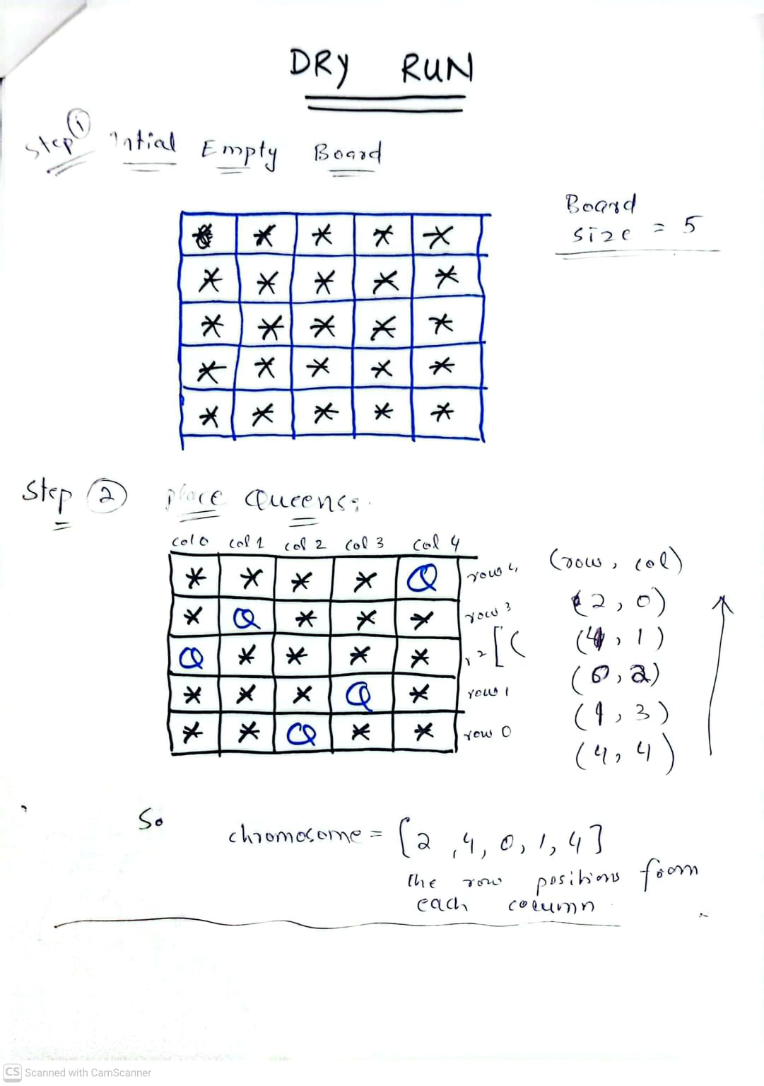

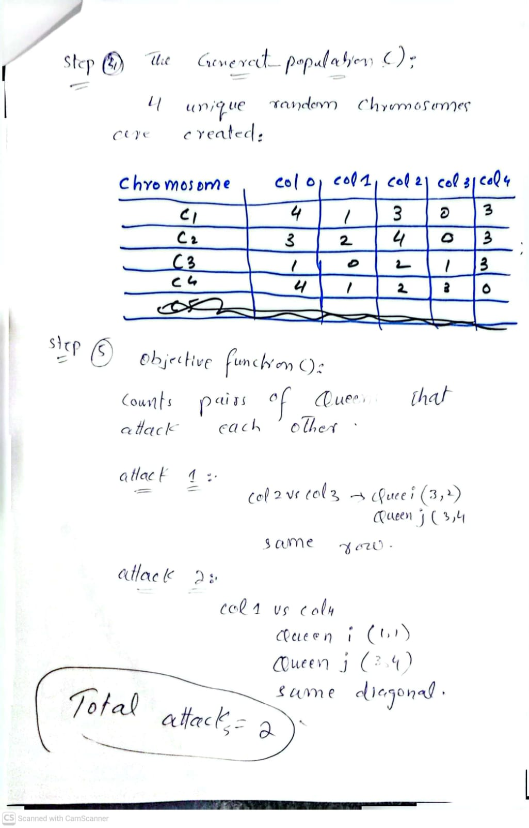
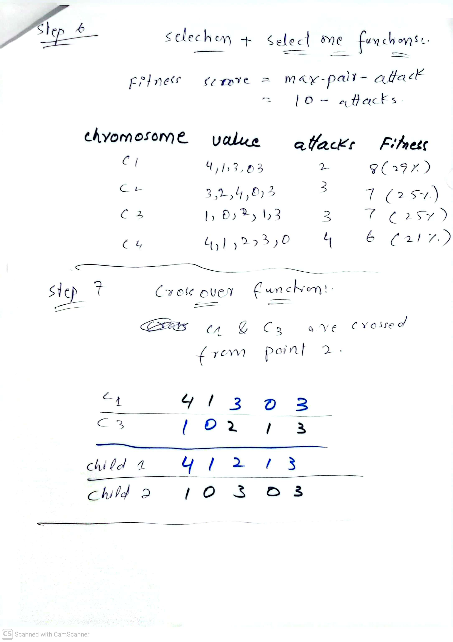
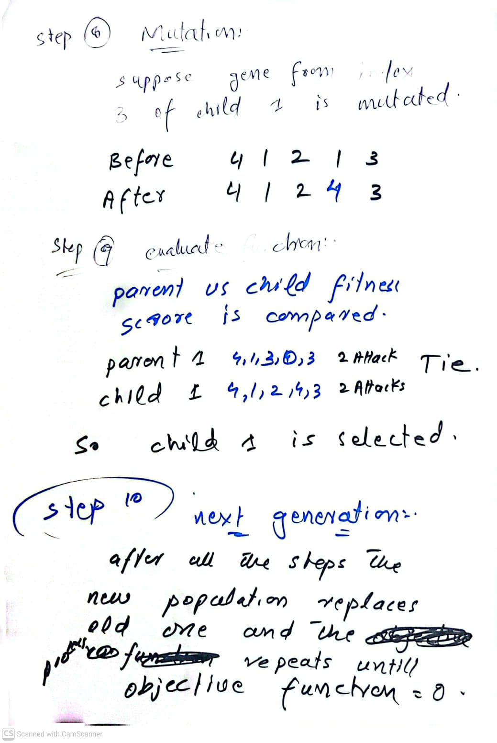
Task 4:
Briefly explain with the help of code that how Genetic Algorithm is helpful in solving N Queen problem

The N-Queen Problem
The N-Queen problem requires placing N queens on an N x N chessboard such that no two queens attack each other — meaning no two queens share the same row, column, or diagonal. For N=8, there are over 4 billion possible arrangements, making brute-force search impractical.

Why Genetic Algorithm is Suitable
The Genetic Algorithm (GA) is well-suited to solve the N-Queen problem for the following reasons:

- Large search space: With N=8, there are 8^8 = 16 million possible placements. GA does not search all of them — it intelligently explores promising regions.
- Fitness-guided search: The objective function counts attacking pairs. GA uses this to favour chromosomes with fewer conflicts, naturally moving toward the solution.
- Parallel exploration: GA maintains a population of solutions simultaneously. This avoids getting stuck in one bad local region.
- Crossover combines good partial solutions: Two chromosomes that each solve part of the board can be combined to produce a child that solves more of it.
- Mutation maintains diversity: Random gene changes prevent the entire population from converging on a non-optimal solution.

How the Code Implements This
The run_ga() function ties all components together in the following loop:

How the Code Implements This:
The run_ga() function ties all components together in the following loop:

1. generate_population() → Create random initial queen arrangements
2. fitness_from_chrom() → Count attacking pairs for each arrangement
3. selection() → Pick better arrangements to be parents
4. crossover() → Combine two parents into two children
5. mutation() → Randomly tweak some queen positions
6. Evaluate() → Keep child only if it is better than parent
7. Repeat steps 2-6 → Until 0 attacking pairs (perfect solution)

Conclusion
The Genetic Algorithm is highly effective for the N-Queen problem because it mimics natural evolution — bad solutions die off, good solutions reproduce and improve across generations.

